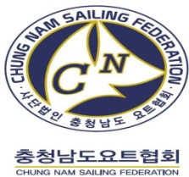

2022 ASAF KEELBOAT CUP & BORYEONG
INTERNATIONAL SAILING CHAMPIONSHIP (J70)
19th JUL TO 25th JUL 2022

Boryeong Sailing Centre, Daechun Beach, Republic of Korea
Hosted by the Chungcheongnam-do Sailing Federation

SAILING INSTRUCTIONS (SIs)

The Organizing Authority (OA) is the 2022 ASAF Keelboat Cup & Boryeong International Yacht Championship Organizing Authority, Sponsors of the Ministry of Maritime Affairs and Fisheries, Province of Chungcheongnam-do, Bryeong City, Asian Sailing Federation, Korea Sailing Federation, Korean Sport & Olympic Committee.

1 RULES
1.1 The event is governed by the rules as defined in The Racing Rules of Sailing.
1.2 Class Rules will apply except C3.1 and C3.2.
1.3 RRS Appendix P, Special Procedure for RRS 42 will apply.
1.4 The crew shall consist of at 4 persons (Max 360kg) and the number of crew shall not be changed during the event.
1.5 Spot checks may be conducted during the event to verify compliance with these rules and regulations.
1.6 National Prescription 2 'RRS 67 Damages' will apply. (Any issue of liability or claim for damages, injury or death arising from an incident is subject to the jurisdiction of the courts and is never an object of a decision by a PC, an Appeals Committee or OA.)
1.7 The meaning of the notations used in all the documents related to this event are as follows;
(a) [SP] denotes a rule for which a standard penalty may be applied by the Race Committee without a hearing, or a discretionary penalty applied by the jury with a hearing. This changes RRS 63.1 and A5.
(b) [NP] denotes a rule that shall not be grounds for protests by a boat. This changes RRS 60.1(a).
1.8 If there is a conflict between NoR and SI, SI will take precedence. This changes RRS 63.7.
1.9 If there is a conflict between languages the English text will take precedence
2 CHANGES TO SAILING INSTRUCTIONS
2.1 Any change to the sailing instructions will be posted before 09:00 on the day it will take effect, except that any change to the schedule of races will be posted by 20:00 on the day before it will take effect.
2.2 At sea, the change to SI may be notified to the boats by displaying 'flag L’ with one sound signal at the RC vessel.
3 COMMUNICATIONS WITH COMPETITORS
3.1 Notices to competitors will be posted on the official notice board located at the headquarters.
3.2 Notification of 3.1 may be notified to each team via messenger service designated by the Race Committee. However, the messenger service does not replace clause 3.1 just because it is not announced as an auxiliary service for athletes.
3.3 The race office is located at Mud square in Daechun beach.
4 CODE OF CONDUCT
4.1 [NP][DP] Competitors and support persons shall comply with reasonable requests from race officials.
4.2 [NP][DP] Competitors and support persons shall [handle any equipment] or [place advertising provided] by the organizing authority with care, seamanship, in accordance with any instructions for its use and without interfering with its functionality.
5 SIGNALS MADE ASHORE
5.1 Onshore signals will be displayed on the flagpole in front of the competition headquarters.
5.2 When flag AP is displayed ashore, ‘1 minute’ is replaced with ‘not less than 40 minutes’ in Race Signals AP.
5.3 [NP][DP] All participating teams are allowed to sail from the harbor after the 'flag D' is lowered. Flag D with one sound means ‘Boats are requested not to leave the harbor until this signal is made.
6 SCHEDULE OF RACES
6.1 The schedule is as follows:

Date | Event
19th July  (Tue) | ∙ Official Arrival | - Team photo
20th July  (Wed) | ∙ Registration 09:00 – 12:00  ∙ Boat Charter 09:00 – 12:00  ∙ Practice Race 14:00 – 17:00 | - Race boat draw
21st July  (Thu) | ∙ Skipper Meeting 09:00 - 09:30  ∙ First warning signal 09:55
22nd July  (Fri) | ∙ Skipper Meeting 09:00 - 09:30  ∙ First warning signal 09:55  ∙ Opening Ceremony 17:00 | - Opening Ceremony
23rd July  (Sat) | ∙ Skipper Meeting 09:00 - 09:30  ∙ First warning signal 09:55  ∙ City Tour and Tourism 14:00 – 18:00 | - Reserve day (in tour)
24th July (Sun) | ∙ Skipper Meeting 09:00 - 09:30  ∙ Racing: First warning signal 09:55  ∙ Award Ceremony 16:00 | - Award Ceremony
25th July (Mon) | ∙ Departure
6.2 The scheduled time of the warning signal for the first race each day is 09:55.
6.3 To alert boats that a start sequence will begin soon, the orange-colored starting line flag will be displayed with one sound at least five minutes before a warning signal is made.
6.4 On the last scheduled day of racing no warning signal will be made after 13:55.
7 CLASS FLAGS
7.1 The Class flag will be a white flag with the J70 class logo.
8 RACING AREA
8.1 SI “Attachment A” shows the location of the racing area(s).
9 COURSES
9.1 The diagram in SI “Attachment B” shows the course, including the order in which marks are to be passed, and the side on which each mark is to be left.
9.2 No later than the warning signal, the Race Committee vessel will display the approximate compass bearing of the first leg.
9.3 [DP][NP] The windward mark are set with Mark-1 and Mark 1-a. Downwind sails (gennaker) shall not be used between Mark-1 and Mark 1-a.
9.4 If flag C is displayed together with a red flag and repeated sound signals at the leeward mark, the position of mark 1 has changed. The new mark 1 will be same color as the flag. This changed RRS 33.
10 MARKS
10.1 Mark(s)
Class | Mark 1  (Windward M) | Mark 1-a  (Windward-1) | Mark 2  (Leeward M) | Start & Finish
J70 | Yellow  (Cube) | Orange  (Cone) | Yellow  (Cube) | White  (Cone)

10.2 When changing the next leg of the course, the changed mark is a red cone.
10.3 There is no offset mark (1-a) of the changed course.
11 OBSTRUCTIONS
11.1 Boundary marks are designated as obstructions: Yellow (cylindrical)
11.2 Reefs and shallow waters are designated as obstructions: Orange (fender ball)
11.3 Indication of reefs and shallow is subject to change at skipper meetings. This clause supersedes clause 11.1, 11.2
12 THE START
12.1 Races will be started using RRS 26 with the warning signal made 5 minutes before the starting signal.
12.2 The starting line will be between a staff displaying an orange flag on the RC vessel at the starboard end and the course side of port-end starting mark.
12.3 A boat starting later than 4 minutes after her starting signal will be
scored DNS without a hearing. This changes RRS A4, A5
13 THE FINISH
13.1 A blue flag flown from the Race Committee vessel will indicate the finishing vessel is on station for the finish.
13.2 The finishing line will be between blue flag of the Race Committee vessel and the course side of the finishing mark.
13.3 RC vessel will be on the port end of finish line when viewed from Marks 1 and 1-a.
14 PENALTY SYSTEM
14.1 RRS 44.1 is changed so that the Two-Turns Penalty is replaced by the One-Turn Penalty. And breach of the RRS P2 is also One-Turn Penalty.
15 TIME LIMITS AND TARGET TIMES
15.1 The Mark 1 Time Limit, Race Time Limit (see RRS 35), and the Finishing Window are shown in the table below.
Mark 1 Time Limit | Race Time Limit | Finish Window | Race Target Time
15 min | 55 min | 10 min | 40 min
15.2 If no boat has passed Mark 1 within the Mark 1 Time Limit, or no boat has finished within the race time limit, the race shall be abandoned under RRS 35.
15.3 The Finishing Window is the time for boats to finish after the first boat sails the course and finishes. Boats failing to finish with in the Finishing Window, and not subsequently retiring, penalized or given redress, will be scored Time Limit Expired (TLE) without a hearing. A boat which scored TLE shall be scored points for the finishing place two more points scored by the last boat that finished within the Finishing Window. This changes RRS 35, A5.1, A5.2 and A10.
15.4 Failure to meet the Target Time will not be grounds for redress. This changes RRS 62.1(a).
16 PROTESTS AND HEARING REQUESTS
16.1 In addition to the requirements of RRS 61.1 “Informing the Protested, a boat intending to protest shall also inform the Race Committee vessel of that intention as soon as possible. If it is not possible, boats intending to protest shall submit an immediate statement to Protest Committee after returning ashore. (Protest flag 25×20Cm)
16.2 The protest time limit is 60 minutes after the last boat finishes the last race of the day or the Race Committee signals no more racing today, whichever is later. The time will be posted on the official notice board.
16.3 Protest forms are available from the jury room
16.4 Notices will be posted no later than 30 minutes after the protest time limit to inform competitors of hearings in which they are parties or named as witnesses.
16.5 A list of boats that have been penalized for breaking RRS 42 under Appendix P will be posted.
16.6 Decisions of the international jury will be final as provided in RRS 70.5.
17 SCORING
17.1 One race is required to be completed to constitute an Event.
17.2 The invitation race results are not included in calculating boat’s final scores.
17.2 Competitors who believe that the scoring of a race is incorrect must state the grounds on the scoring correction request form and submit it to the race office. See RRS 90.3(c).
18 SAFETY REGULATIONS AND HANDLING THE BOAT
18.1 There is no specific Check-Out and Check-In.
18.2 [NP][DP] A boat that retires from a race shall notify the Race Committee as soon as possible.
18.3 [NP][DP] Competitors, Race Officials and Support persons shall wear personal flotation device properly secured at all times while afloat, except when temporarily adding or removing clothing or personal equipment. This changes RRS 40 and Preamble of Part 4.
18.4 [NP][DP] To a boat that strays out the safe race area the Safety Guide Boat or RESCUE Boat will order to return to the safe race area with raising Y flag and whistle sound. The boat that does not follow this order can be protested.
18.5 [NP][DP] When flag ‘Y’ is displayed on RC, gennakers shall not be used while racing.
19 REPLACEMENT OF CREW OR EQUIPMENT
19.1 Final Crew members who have applied for on-site registration for final matches shall not be substitute during the race. In the case of inevitable circumstances such as illness, a crew exchange may be approved by the O.A only if a team submitted a written request before the relevant competition.
19.2 At least three persons shall be on board for the qualifying competition.
19.3 Foreign crew must be on board for all rounds.
19.4 In case of a replacement crew member for the final match, the crew member must be registered on the entry form. In no case it is acceptable to change or add crew members after the start of the competition, which includes foreigners and the skippers.
19.5 If it is necessary to replace the crew listed in the application form, the O.A shall be notified of the reason for the replacement until 11th of July, and approved after screening by the O.A. The O.A will not accept any crew replacements except under special circumstances, such as an injury of a competitor.
19.6 [NP][DP] Substitution of competitors is not allowed without prior written approval of the Race Committee.
19.7 [NP][DP] Substitution of damaged or lost equipment is not allowed unless authorized in writing by the Race Committee. Requests for substitution shall be made to the Race Committee at the first reasonable opportunity, which may be after the race.
20 EQUIPMENT AND MEASUREMENT CHECKS
20.1 Use of the charter boat provided by the Organizing Authority. (Refer to SI “Addendum A”)
20.2 Five race boats will be provided, and the competition will take place in a fleet race rotation when five or more teams participate.
21 SUPPLIED BOATS
21.1 O.A may offer berths for coach or support vessels within its marina for the duration of the regatta.
21.2 Coaches and support boats shall stay at least 100m outside the race area from the preparatory signal to the finish.
21.3 Competitors shall have no communication with coach or support vessels during the race.
21.4 If called upon by the race officer, support boats must assist in an emergency as directed.
22 OFFICIAL VESSELS
22.1 Official vessels will be identified by a flag designated by the OA
23 [DP][NP] TRASH DISPOSAL
23.1 Boats shall not intentionally put trash in the water. Trash may be placed aboard support or official boats. See RRS 47.
24 [DP] BERTHING
24.1 Boats shall be kept in their assigned places while in the [boat park][harbour].
25 [DP] HAUL-OUT RESTRICTIONS
25.1 Boats shall not be hauled out during the event except with and according to the terms of prior written permission of the Race Committee.
26 DIVING EQUIPMENT AND PLASTIC POOLS
26.1 Underwater breathing apparatus and plastic pools or their equivalent shall not be used around keelboats between the preparatory signal of the first race and the end of the last race of the event.
27 PRIZES
27.1 Prizes will be given [in each class] for <list place(s)>.
Placing | Prizes | Placing | Prizes
1 | 10,000,000Won (￦) | 6 | 1,300,000 Won(￦)
2 | 7,000,000 Won(￦) | 7 | 1,000,000 Won(￦)
3 | 5,000,000 Won(￦) | 8 | 800,000 Won(￦)
4 | 3,000,000 Won(￦) | 9 | 700,000 Won(￦)
5 | 2,000,000 Won(￦) | 10 | 600,000 Won(￦)
27.2 Trophies will be awarded from 1st to 3rd place finishers in the finals. Prizes for the qualifying and finals will be awarded at the award ceremony on 24th July 2022.
27.3 All teams participating in the competition must have at least two sailors (including a skipper and a foreign crewman) to represent their teams at the opening ceremony. No prize money will be given in the case of non-participation.
27.4 Boats tied for the regatta shall share the prize money according to RRS A7.
27.5 General Rule
(a) Tax will be deducted for Korean.
(b) For non-Korean, tax will be deducted as per tax agreement between Korea and the recipient’s country.
(c) For all winners, up to 5% of their prize money will be donated to Greenpeace.
(d) Prize money will be sent by bank transfer to the recipient’s bank account within 20 days after the event.
(e) Prize money will be sent to only the recipient stated on the entry form.
27.6 Additional prizes may be awarded at the discretion of OA.
28 DISCLAIMER OF LIABILITY
28.1 Competitors participates in the regatta entirely at their own risk. See RRS 3 'Decision to Race'. Chungnam Sailing Federation and the Organizing Authority will not accept any liability for material damage or personal injury or death sustained in conjunction with or prior to, during, or after the regatta.
29 INSURANCE
29.1 Insurance subscription for crews participating in the main competition shall be provided by the Organizing Authority, and personal information on crews necessary for insurance subscription shall be submitted to the Organizing Authority.
30 COVID-19 STATEMENT
30.1 During the competition, each athlete agrees and acknowledges that he or she is responsible for complying with the government policy & Organizing Authority guidelines and procedures associated with COVID-19.
SI ADDENDUM A

BOATS SUPPLIED BY THE ORGANIZING AUTHORITY

A1.1 Five boats will be supplied for all teams, who shall not modify them or cause them to be modified in any way except that
(a) A compass may be tied or taped to the hull or spars.
(b) Wind indicators, including yarn or thread, may be tied or taped anywhere on the boat.
(c) Hulls, centerboards and rudders may be cleaned, but only with water.
(d) Adhesive tape may be used anywhere above the water line; and
(e) All fittings or equipment designed to be adjusted may be adjusted, provided that the class rules are complied with.
A1.2 All equipment supplied with the boat for sailing purposes shall be in the boat while afloat.
A1.3 The penalty for not complying with one of the above instructions is disqualification from all races sailed in which the instruction was broken.
A1.4 Competitors shall report any damage or loss of equipment, however slight, to the organizing authority’s representative immediately after securing the boat ashore. The penalty for breaking this instruction, unless the Protest Committee is satisfied that the competitor made a determined effort to comply, is disqualification from the race most recently sailed.
A1.5 Class rules requiring competitors to be members of the class association do not apply.

ATTACHMENT A – RACING AREA

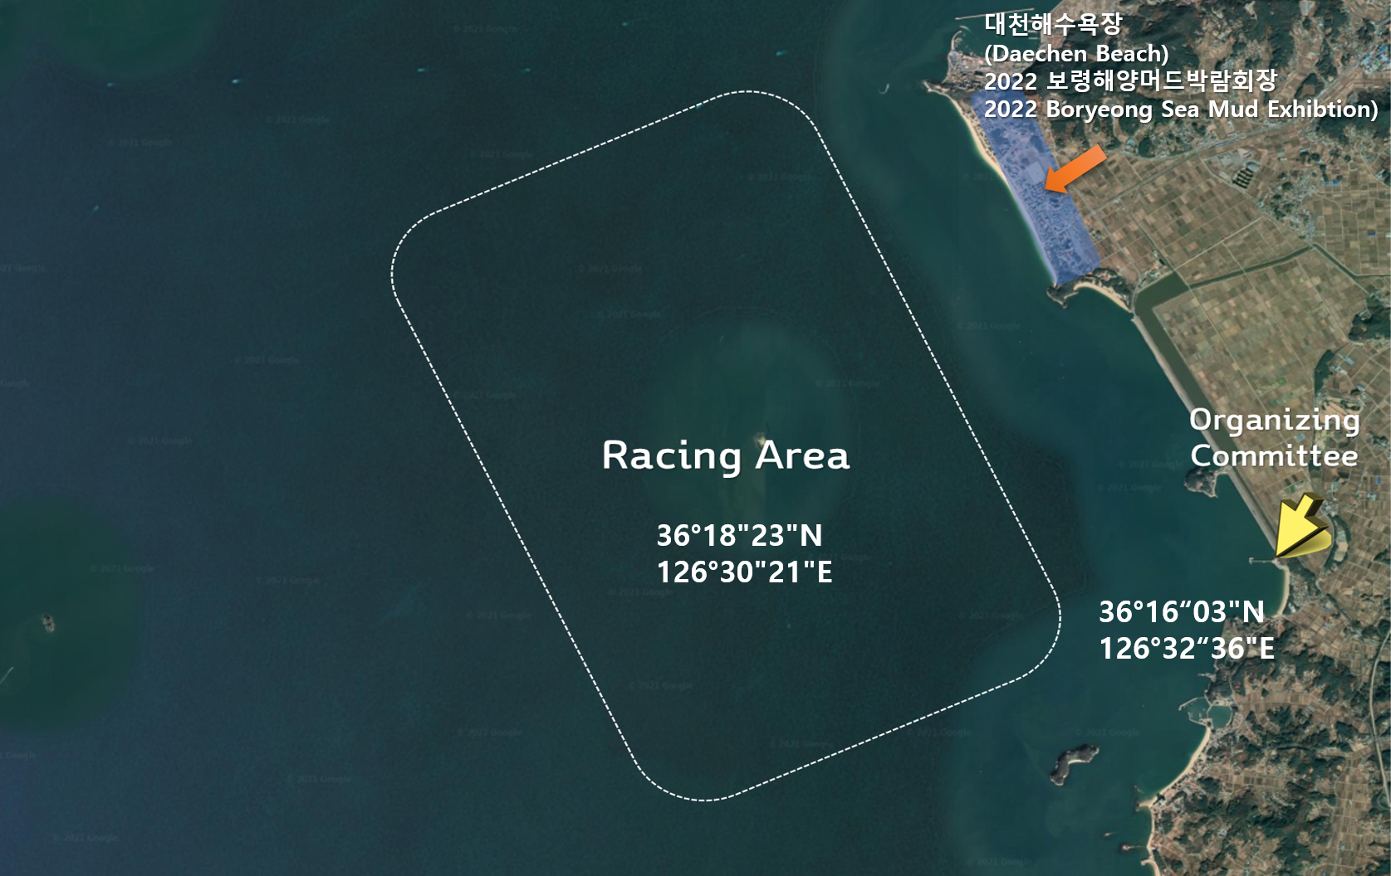

ATTACHMENT B – COURSE

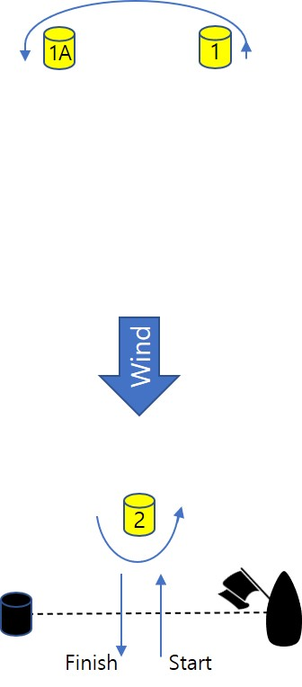 | Course Windward-Leeward with downwind Finish  I-1 Start – 1 – 1A - Finish  I-2 Start – 1 – 1A – 2 – 1 – 1A - Finish  I-3 Start – 1 – 1A – 2 – 1 – 1A - 2 – 1 – 1A - Finish  ※ The start / finish line will be laid approximately 50~100m to leeward of marks 2.

