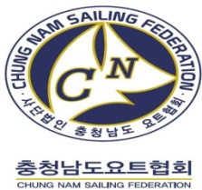

2022 ASIAN CUP & BORYONG INTERNATIONAL SAILING CHAMPIONSHIP (OPTIMIST)
Boryeong Sailing Centre, Daechun Beach, Republic of Korea
20th JUL TO 25th JUL 2022

ORGANIZING AUTHORITY (OA):
The Organising Authority (OA) is the Chunngcheonnam-do Sailing Federation (CSAF). in conjunction with the 2022 ASAF Keelboat Cup & Boryeong International Sailing Championship Organizing Authority under the authorization and delegation of the Asian Sailing Federation (ASAF).
Sponsors are the Ministry of Maritime Affairs and Fisheries, Province of Chungcheongnam-do, Bryeong City, Asian Sailing Federation, Korea Sailing Federation and Korean Sport & Olympic Committee.

SAILING INSTRUCTIONS (SIs)

1 RULES
1.1 The event is governed by the rules as defined in The Racing Rules of Sailing.
1.2 No national prescriptions will apply.
1.3 Optimist Class rules will apply.
1.4 RRS Appendix P, Special Procedure for RRS 42 will apply.
1.5 The meaning of the notations used in all the documents related to this event are as follows.
(a) [SP] denotes a rule for which a standard penalty may be applied by the Race Committee or Technical Committee without a hearing, or a discretionary penalty applied by the jury with a hearing. This changes RRS 63.1 and A5.
(b) [NP] denotes a rule that shall not be grounds for protests by a boat. This changes RRS 60.1(a).
1.6 If there is a conflict between NoR and SI, SI will take precedence. This changes RRS 63.7.
1.7 If there is a conflict between languages the English text will take precedence
1.8 [DP] Technical Committee are responsible for Measurement Protests as per RR64.4 b (Graded penalty system of the IODA)

2 CHANGES TO SAILING INSTRUCTIONS
2.1 Any change to the sailing instructions will be posted before 08:30 on the day it will take effect, except that any change to the schedule of races will be posted by 20:00 on the day before it will take effect.
2.2 At sea, the change to SI may be notified to the boats by displaying 'flag L’ with one sound signal at the RC vessel.

3 COMMUNICATIONS WITH COMPETITORS
3.1 Notices to competitors will be posted on the official notice board located at the headquarters.
3.2 Notification of 3.1 may be notified to each team via messenger service designated by the Race Committee. However, the messenger service does not replace clause 3.1 just because it is not announced as an auxiliary service for competitors.
3.3 The race office is located at Boryeong Sailing Center.

4 CODE OF CONDUCT
4.1 [NP][DP] Competitors and support persons shall comply with reasonable requests from race officials.
4.2 [NP][DP] Competitors and support persons shall [handle any equipment] or [place advertising provided] by the organizing authority with care, seamanship, in accordance with any instructions for its use and without interfering with its functionality.

5 SIGNALS MADE ASHORE
5.1 Onshore signals will be displayed on the flagpole in front of the competition headquarters.
5.2 When flag AP is displayed ashore, ‘1 minute’ is replaced with ‘not less than 60 minutes’ in Race Signals AP.
5.3 [NP][DP] All participating teams are allowed to sail from the harbor after the 'flag D' is lowered. Flag D with one sound means ‘Boats are requested not to leave the harbor until this signal is made.

6 SCHEDULE OF RACES

6.1 Program:
Date | Warning signal for the first race | Races  per day
20th July (Wed) | ∙ Arrival
21st July (Thu) | ∙ Registration/Boat Charter &  Measurement 09:00 - 18:00  ∙ Practice Sailing (14:00 to 17:00)
22nd July (Fri) | ∙ Skipper Meeting 08:30  ∙ Race: First warning signal 09:55  ∙ Opening Ceremony & Welcome Dinner 17:00 | 3
23rd July (Sat) | ∙ Skipper Meeting 08:30  ∙ Race: First warning signal 09:55  ∙ City Tour and Tourism 14:00 – 18:00 | 2
24th July (Sun) | ∙ Skipper Meeting 08:30  ∙ Race: First warning signal 09:55  ∙ Award Ceremony & Dinner Party 17:00 | 3
25th July (Mon) | ∙ Departure

6.2 The scheduled time of the warning signal for the first race each day is 09:55.
6.3 To alert boats that a start sequence will begin soon, the orange-colored starting line flag will be displayed with one sound at least five minutes before a warning signal is made.
6.4 On the last scheduled day of racing no warning signal will be made after 12:55.
6.5 8 races are scheduled

7 CLASS FLAGS
7.1 The Class flag will be a Boy is white flag with the Black OP class logo and Girl is white flag with the Red OP class logo.

8 RACING AREA
8.1 SI “Attachment A” shows the location of the racing area(s).

9 COURSES
9.1 The diagram in SI “Attachment B” shows the course, including the order in which marks are to be passed, and the side on which each mark is to be left.
9.2 No later than the warning signal, the Race Committee vessel will display the approximate compass bearing of the first leg.

10 MARKS
10.1 Mark(s)

Class | Course Mark | New Mark | Finish
Optimist | YELLOW cylinder | RED cone | WHITE cone

11 OBSTRUCTIONS
11.1 Boundary marks are designated as obstructions: Yellow (stick)
11.2 Reefs and shallow waters are designated as obstructions: Orange (fender ball)
11.3 Indication of reefs and shallow is subject to change at skipper meetings. This clause supersedes clause 11.1 & 11.2

12 THE START
12.1 Races will be started using RRS 26 with the warning signal made 5 minutes before the starting signal.
12.2 The starting line will be between a staff displaying an orange flag on the RC vessel at the starboard end and the course side of Pin End Boat with Bravo Flag.
12.3 [NP][DP] When the warning signal for the first fleet has been made, boats from the other fleets shall be in or downwind of the waiting area. Boats starting next may approach the starting line after the start of the previous fleet.
12.4 [DP] Boats that have finished shall return directly to the waiting area or ashore, keeping well clear of all boats racing and of all boats whose warning signal has been made.
12.5 A boat starting later than 4 minutes after her starting signal will be scored DNS without a hearing. This changes RRS A5.1, A5.2.
12.6 The starting order of the fleets will be Boy and Girl.

13 THE FINISH
13.1 The finishing line will be between staff displaying blue flags on the RC vessel & white cone mark.

14 PENALTY SYSTEM
14.1 RRS Appendix P will apply as changed by SI 14.2.
14.2 RRS P2.3 will not apply and RRS P2.2 is changed so that it will apply to any penalty after the first one.
14.3 [SP] The penalty for a breach of Class Rule will be Standard Penalty, [SP], which changes rule RRS 63.1 and A 5.1 and may also be less than disqualification. The IODA Graded penalty system of 2022 Optimist World will apply.

15 TIME LIMITS [AND TARGET TIMES]
15.1 The Mark 1 Time Limit, Race Time Limit (see RRS 35), and the Finishing Window are shown in the table below.
Mark 1  Time Limit | Race  Time Limit | Finishing  Window | Race  Target Time
20 min | 50 min | 20 min | 35 min

15.2 If no boat has passed Mark 1 within the Mark 1 Time Limit, or no boat has finished within the race time limit, the race shall be abandoned under RRS 35.
15.3 The Finishing Window is the time for boats to finish after the first boat sails the course and finishes. Boats failing to finish within the Finishing Window, and not subsequently retiring, penalized, or given redress, will be scored ‘DNF’ without a hearing. This changes RRS 35, A4 and A5.
15.4 Failure to meet the Target Time will not be grounds for redress. This changes RRS 62.1(a).

16 PROTESTS AND HEARING REQUESTS
16.1 In addition to the requirements of RRS 61.1 “Informing the Protested, a boat intending to protest shall also inform the Race Committee vessel of that intention as soon as possible. If it is not possible, boats intending to protest shall submit an immediate statement to Protest Committee after returning ashore.
16.2 The protest time limit is 60 minutes after the last boat finishes the last race of the day or the Race Committee signals no more racing today, whichever is later. The time will be posted on the official notice board.
16.3 Protest forms are available from the jury room.
16.4 Notices will be posted no later than 30 minutes after the protest time limit to inform competitors of hearings in which they are parties or named as witnesses.
16.5 A list of boats that have been penalized for breaking RRS 42 under Appendix P will be posted.
16.6 Decisions of the International Jury will be final as provided in RRS 70.5.

17 SCORING
17.1 One race is required to be completed to constitute a event.
17.2 When fewer than five races have been completed, a boat’s series score will be the total of her race scores.
17.3 When five or more races have been completed, a boat’s series score will be the total of her race scores excluding her worst score.
17.4 Competitors who believe that the scoring of a race is incorrect must state the grounds on the scoring correction request form and submit it to the race office. See RRS 90.3(c).

18 SAFETY REGULATIONS AND HANDLING THE BOAT
18.1 [NP][SP] Check-Out and Check-In Procedures:
18.1.1 Before launching on each scheduled racing day, a competitor from each boat shall personally Check-Out, by signing on the forms placed at the Beach Master desk at the launching area.
18.1.2 After returning ashore, a competitor from each boat shall personally Check-In, by signing on the forms placed at the Beach Master desk, within the protest time limit.
18.1.3 Penalties for breaches of rules marked [SP] will be

Sailing Instructions | Penalty | Score to be added
18.1.1 (Check Out) | 2 | To the first completed race of the day for failure to check out.
18.1.2 (Check In) | 2 | To the last completed race of the day for failure to check in.
(If there is only one race completed that day total penalty point will be 1 for breaching SI 18.1.1 & 18.1.2)
18.2 [NP][DP]A boat that retires from a race shall notify the Race Committee as soon as possible.
18.3 [NP][DP] Competitors, Race Officials and Support persons shall wear personal flotation device properly secured at all times while afloat, except when temporarily adding or removing clothing or personal equipment. This changes RRS 40 and Preamble of Part 4.
18.4 [NP][DP] To a boat that strays out the safe race area the Safety Guide Boat or Rescue Boat will order to return to the safe race area with raising V flag and whistle sound. The boat that does not follow this order can be protested.

19 [DP] REPLACEMENT OF EQUIPMENT
19.1 Substitution of damaged or lost equipment is not allowed unless authorized in writing by the Technical Committee. Requests for substitution shall be made to the committee at the first reasonable opportunity, which may be after the race.

20 EQUIPMENT AND MEASUREMENT CHECKS
20.1 A boat or equipment may be inspected at any time for compliance with the class rules, notice of race and sailing instructions.
20.2 [DP] When instructed by a technical official on the water, a boat shall proceed to a designated area for inspection.

21 SUPPLIED BOATS
21.1 OA may offer berths for coach or support vessels within its marina for the duration of the regatta.
21.2 Coaches and support boats shall stay at least 100m outside the race area from the preparatory signal to the finish.
21.3 Competitors shall have no communication with coach or support vessels during the race.
21.4 If called upon by the race officer, support boats must assist in an emergency as directed.

22 OFFICIAL VESSELS
22.1 Official vessels will be identified by a flag designated by the OA

23 [NP][DP] TRASH DISPOSAL
23.1 Boats shall not intentionally put trash in the water. Trash may be placed aboard support or official boats. See RRS 47.

24 [NP][DP] BERTHING
24.1 Boats shall be kept in their assigned places while in the [boat park][harbour].

25 PRIZES
25.1 Prizes winners for the Optimist class will obtain merchandise worth the amount stated as follows (Currency: won)
Class | Placing |  | Merchandise
 |  |  | Youth I(U12) | Youth II(U15)
Optimist | Overall |  | 13,200,000
 | Boy | 1 | 1,000,000 | 1,000,000
 |  | 2 | 800,000 | 800,000
 |  | 3 | 600,000 | 600,000
 |  | 4 | 500,000 | 500,000
 |  | 5 | 400,000 | 400,000
 | Girl | 1 | 1,000,000 | 1,000,000
 |  | 2 | 800,000 | 800,000
 |  | 3 | 600,000 | 600,000
 |  | 4 | 500,000 | 500,000
 |  | 5 | 400,000 | 400,000
Total |  |  | 13,200,000

25.2 Awards for Youth I(U12), Youth II(U15) and male and female will be provided on awards ceremony on 24th July 2022.
25.3 Additional prizes may be awarded at the discretion of O.A.

26 DISCLAIMER OF LIABILITY
26.1 Competitors participates in the regatta entirely at their own risk. See RRS 3 'Decision to Race'. Chungnam Sailing Federation and the Organizing Authority will not accept any liability for material damage or personal injury or death sustained in conjunction with or prior to, during, or after the regatta.

27 INSURANCE
27.1 Insurance subscription for crews participating in the main competition shall be provided by the Organizing Authority, and personal information on crews necessary for insurance subscription shall be submitted to the Organizing Authority.

28 COVID-19 STATEMENT
28.1 During the competition, each athlete agrees and acknowledges that he or she is responsible for complying with the government policy & Organizing Authority guidelines and procedures associated with COVID-19.
ATTACHMENT A – RACING AREAS

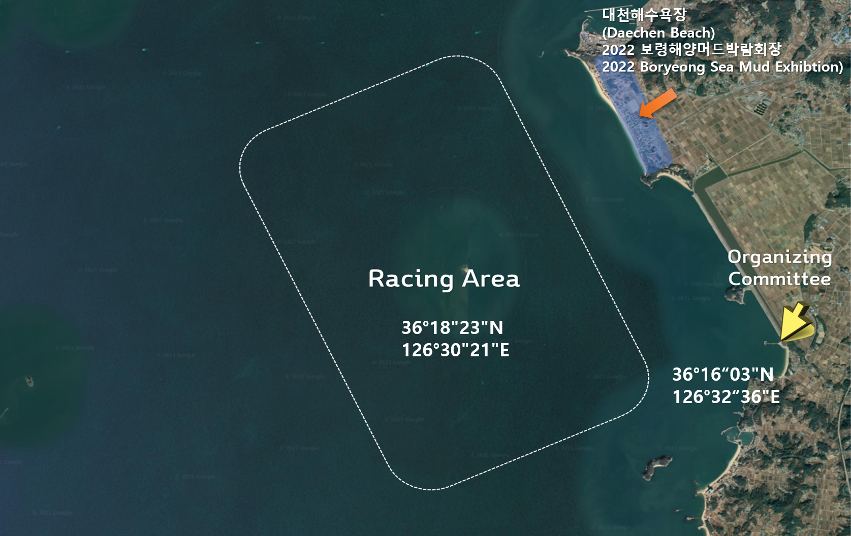
OP
Racing
Area
J70
Racing
Area

ATTACHMENT B – COURSE

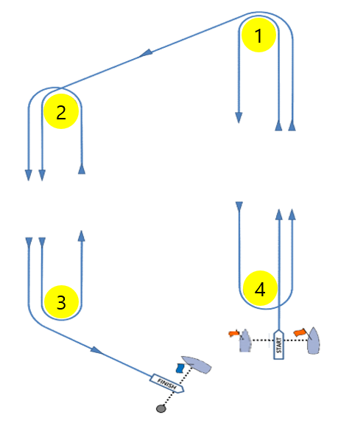
Course Signal | Trapezoid Course Mark Rounding Order
O 1 | Start – 1 – 2 – 3 – Finish
O 2 | Start – 1 – 2 – 3 – 2 – 3 - Finish
O 3 | Start – 1 – 2 – 3 – 2 – 3 – 2 – 3 – Finish
I 2 | Start – 1 – 4 – 1 – 2 – 3 – Finish
I 3 | Start – 1 – 4 – 1 – 4 – 1 – 2 – 3 – Finish

