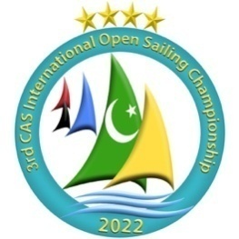

3rd CAS INTERNATIONAL OPEN SAILING CHAMPIONSHIP 2022
16 To 20 March, 2022

ORGANIZING AUTHORITY
The Organizing Authority (OA) is the Pakistan Air Force YachtClubwith the support of Pakistan Sailing Federation.
SAILING INSTRUCTIONS
1 RULES
1.1 The Championship will be governed by the rules as defined in the Racing Rules of Sailing 2021-2024.
1.2 RRS Appendix P, Special Procedures for RRS 42 will apply.
1.3 No national prescriptions will apply.
1.4 The first three sentences of RRS 61.1 (a) are changed to “a boat intending to protest shall inform the other boat at the first reasonable opportunity. When her protest will concern an incident in the racing area that she was involved in or so she shall have “Protest”. She shall inform race committee at the finishing line immediately after finishing of the boat/s being protested or as soon as practicable after she retires”.
1.5 If there is a conflict between languages the English text will take precedence.
1.6.1 Both “athlete” and “competitor” mean a person competing or intending to compete in the event.
1.6.2 The “support team” means coaches, team leaders and other support personnel.
1.6.3 [DP] denotes a rule for which the penalty is applied according to the RRS introduction- Notation.
1.6.4 [SP] denotes a rule for which a standard penalty may be applied by the Race Committee or PC.without a hearing or a discretionary penalty applied by the International Jury with a hearing. This changes RRS 63.1 and A5.
1.6.5 [NP] denotes a rule that shall not be grounds for protests by a boat. This changes RRS 60.1(a).
1.7 Penalties for breaches of RRS 41, Class Rules or the Equipment Regulations (ER) are at the discretion of the international jury.
1.8 [NP] The infringement of RRS Appendix G, IDENTIFICATION ON SAILS, shall not be grounds for protests by a boat.
1.9 [DP][NP] Protocols relating to COVID-19 maybe published at anytime and have the status of a rule.

2 [DP] [NP] EVENT ADVERTISING
2.1 Competitor advertising will be restricted to World Sailing Regulation 20, Advertising Code.
2.2 Boats may be required to display advertising choice supplied by the Organizing Authority. If this rule is broken, World Sailing Regulation 20.9.2 applies.
2.3 While afloat, competitors maybe required to wear bibs which will be provided by the Organizing Authority and shall display their national letters on the outside of all other clothing and equipment.

3 NOTICES TO COMPETITORS
Notices to competitors and all official communication and requests regarding the event will be posted on the Official Online Notice Board located online at https://www.racingrulesofsailing.org/documents/1067/event. Notices will also be posted on a physical Notice Board located in front of Sailing Hangar.

4 ELIGIBILITY
4.1 The competition is open for the following classes listed below:-
OPTIMIST Open
ILCA 4 Open
ILCA 7 Men
RS:X Men
4.2 Competitors in Optimist Class shall have been born in 2007 or later.
4.3 Competitors in ILCA 4 class shall have been born in 2005 or later.
4.4 Proof of age is required at registration for Optimist and ILCA 4 sailors.
4.5 The entry is open for individuals representing their country.

5 CHANGES TO SAILING INSTRUCTIONS
Any change to the sailing instruction will be posted before 0900 on the day it will take effect, except that any change to the schedule of races will be posted by 2000 on the day before, it will take effect.

6 SIGNALS MADE ASHORE
6.1 Signals made ashore will be displayed at Club Mast located near the slipway.
6.2 When flag AP is displayed ashore, “1 minute” is replaced with “not less than 15 minute “in the race signal AP.
6.3 (DP)(SP) Flag “D" with one sound means” The warning signal will be made not less than 15 minutes after flag D is displayed”. Boats shall not leave their berthing places until this signal is made.

7 FORMAT OF COMPETITION
The competition willconsist of a single series of fleet races.
8 SCHEDULE OF RACES
8.1 Following schedule will be followed:

Date | Day | Schedule
16 March | Wednesday | Arrival of Teams&Officials, Registration
17 March | Thursday | Registration,  Team Leaders / Coaches Meeting,  Races (remove 1,2,3) 1, 2, 3
18 March | Friday | Coaches Meeting,  Races 4, 5, 6
19 March | Saturday | Coaches Meeting,  Race 7, 8, 9
20 March | Sunday | Coaches Meeting,  Races 10  Closing Ceremony ,  Departure

8.2 Maximum number of races will be 10.
8.3 Three races will be sailed a day. One extra race per day may be sailed, provided that no class becomes more than one race ahead of schedule.
8.4 The scheduled time of the warning signal for the first race each day is 1100. The races will may be sailed back to back.
8.5 To alert boats that a race or sequence of races will begin soon, the orange starting line flag will be displayed with one sound at least five minutes before warning signal is made.
8.6 The scheduled time of the coaches meeting each day is 1000 hrs. Meetings will take place in the Briefing Room (Class Room of Sea Survival School)
8.7 On the last scheduled day of racing no warning signal will be made after 1400 hrs.

9 CLASS FLAGS
Following flags will be used

CLASS | FLAG
RS:X | White flag with RSX letters on it
ILCA 7 | White flag with ILCA insignia on it
ILCA 4 | White flag with 4.7 numbers on it
OPTIMIST | White flag with Optimist insignia on it

10 RACING AREAS
Races will be sailed at Korangi Creek in front of PAF Yacht Club. Appendix “A” shows the location of racing area.

11 THE COURSES
11.1 Appendix B shows the courses to be sailed, the order in which the marks are to be passed, the side on which each mark is to be left.
11.2 If there is only one mark in the gate position, this mark shall be left to port.
11.3 No later than the warning signal, the race committee will display the course to be sailed.

12 MARKS
Course Marks Orange sphere cylindrical marks
Change Marks Orange sphere marks with black band around
Pin End Marks Orange round marks

13 THE START
13.1 Races will be started by using RRS 26 with the warning signal made 5 minutes before the starting signal.
13.2 The starting line will be between staff displaying orange flag on the race committee vessel and a the course side of black round mark on port end.
13.3 [DP][NP] Boats whose warning signal has not been made shall avoid the starting area. The starting area is defined as the area 75 meters from the starting line and marks in all directions.
13.4 A boat starting later than four minutes after her starting signal will be scored Did Not Start. This changes RRS A5.1 and A5.2.

14. CHANGE OF THE NEXT LEG OF THE COURSE
14.1 To change the next leg of the course, the race committee will lay a new mark as defined instruction 12 (or move the finishing line) and remove the original mark as soon as practicable.
14.2 Boats shall pass between the race committee vessel signaling the change of course and the nearby mark, leaving the mark to port and the race committee vessel to starboard. This changes RRS 28.1.

15 THE FINISH
The finishing line will be between staff displaying blue flag on the finishing vessel and a the course side of the black mark on the port end.

16 TIME LIMITS AND TARGET TIMES
16.1 The race time limits, target times and finish windows in minutes are as follows:

EVENT | TIME LIMIT | MK 1 TIME LIMIT | TARGET TIME | FINISH WINDOW
OPTIMIST | 50 | 20 | 40 | 20
ILCA 4 | 50 | 20 | 45 | 15
ILCA 7 | 50 | 20 | 45 | 15
RS:X | 45 | 10 | 20 | 10

16.2 The Finishing window is the time for boats to finish after the first boat starts, sails the course and finishes. Boats failing to finish within the Finish Window will be scored Did Not Finish without a hearing. This changes RRS 35, A5.1 and A5.2.
17 PENALTY SYSTEM
17.1 Penalties for breaches of the Class Rules, NOR 16 (Media Rights), the ER, or the rules in SIs marked [DP], are at the discretion of the protest committee and may be less than disqualification.
17.2 A list of SP breaches and the associated standard penalties will be posted. However, the race committee may protest a boat when they consider the standard penalty to be inappropriate. A boat that has been penalized with a standard penalty can neither be protested by another boat for the same incident nor can another boat request redress for this committee action. This changes RRS 60.1, 62.1, 63.1 and A5.
17.3 When a penalty is given under SI 17 before a race is started, the penalty will remain if that race is restarted or re-sailed. This changes RRS 36.
17.4 Penalties for breaches of rules in the Sailing Instructions marked [SP] will be 1 point for each breach. The penalty is applied to each race in which the instruction was infringed.
17.4.1 {SP} Failure to Check-Out will result in 1-point penalty for the next race completed even if no race is completed on the day of the infringement.
17.4.2 Failure to Check-In will result in 1-point penalty for the last race completed even if no race is completed on the day of the infringement.

18 HEARING REQUESTS
18.1 Hearing requests are managed through the online event platform.
18.2 For each fleet the protest time limit is 60 minutes after the last boat finishes the last race of the day, or the race committee signals no more racing today, whichever is later.
18.3 Notices will be posted within 30 minutes of the protest time limit to inform competitors of hearings in which they are parties or named as witnesses. Hearings will be held in the designated jury room beginning at the time posted. Hearings may be scheduled to begin up to 30 minutes before the end of protest time limit. Hearings will be held in the Jury Room located adjacent to briefing room.

18.4 A list of boats that have been penalized under Rule 42 on the water will be posted.
18.5 For the purposes of RRS 64.4(b) the ‘authority responsible’ is the technical committee appointed by the organizing authority.
18.6 RRS 66.2(a)(2) will apply on the last scheduled day of each series.

19 SCORING
19.1 RRS B8 is deleted and RRS Appendix A will apply.
19.2 4 races are required to constitute the competition.
19.3 (a) When up to 5 have been completed, a boats series score will be the total of her race score.
(b) When 6 to 10 races have been completed one discard will be allowed.
20 (DP) SAFETY REGULATIONS
20.1 [SP] Each competitor shall personally Check-Out on the required form, before going afloat each day and Check-In on returning to shore and at the latest by the end of protest time.
20.2 [SP]Optimist must have a towing rope on boat.
20.3 Rule 40.1 applies All competitors shall wear PFD while afloat.
20.4 A boat which retires from a race shall notify the race committee before leaving the race area or when that is not possible Beach Master shall be informed immediately after returning ashore.
20.5 Boats not leaving the shore for the day’s races shall notify the race office as soon as possible by signing a declaration form / by sending an email to pafyachtclub@gmail.com

21 OFFICIAL VESSELS
Official boats will be marked as follows:
21.1 Race committee vessels; white flag with “RC” letters on it.
21.2 Media boat white flag with “MEDIA” letters on it.
21.3 Rescue boat white flag with RESCUE letters on it.
21.4 Jury boats white flag with “JURY” letters on it.
21.5 Repair boat white flag with “REPAIR” letters on it.
21.6 Mark boats white flag with “MARK BOAT” letters on it

22 SUPPORT VESSELS
22.1 Team leaders, coaches and other support personnel shall not be in the area where
boats are racing or within 100 meters of any boat racing from the time of the preparatory
signal for the first fleet to start until all boats have finished even if or the race committee signals a postponement, general recall or abandonment. This instruction does not apply during rescue operations.
22.2 At all times while on water, support vessel shall clearly display either their national flag or their national code letters from both side of the vessel or engine. No other flags or identification shall be displayed by support vessels. The letters will be provided by the Organizing Authority.
22.3 Personnel on board support vessels are required to wear a life jacket or personal floatation device while on the water.
22.4 Support vessels that are motoring at more than 5 knots shall remain at least 150
meters from any boat that is racing.
22.5 Kill cords shall be worn at all times when the engine is running.

23 TRASH DEPOSAL
Trash may be placed aboard support or official boats.

24 RADIO COMMUNICATION [DP][NP]
A boat shall neither make radio transmissions while racing nor receive radio communications not available to all boats. This restriction also applies to mobile telephones.

25 PRIZES
25.1 Gold, Silver and Bronze medals will be awarded to the competitor’s ranked top three at each class.
25.2 Cash prizes for thetop 3 positions are as under:

Class 1stPrize 2ndPrize 3rdPrize
Optimist (Open) $3000 $2000 $1000
ILCA 7 $3000 $2000 $1000
ILCA 4 (Open) $3000 $2000 $1000
RS:X $3000 $2000 $1000
25.3 Other prizes may be awarded by the Organizer.

26 RISK STATEMENT
26.1 RRS 3 of the Racing Rules of Sailing states: “The responsibility for a boat’s decision to participate in a race or to continue racing is hers alone.” Sailing is by its nature an unpredictable sport and therefore inherently involves an element of risk. By taking part in the event, each competitor agrees and acknowledges that:
(a) They are aware of the inherent element of risk involved in the sport and accept responsibility for the exposure of themselves, their crew and their boat to such inherent risk whilst taking part in the event.
(b) They are responsible for the safety of themselves, their crew, their boat and their other property whether afloat or ashore.
(c) They accept responsibility for any injury, damage or loss to the extent caused by their own actions or omission.
(d) Their boat is in good order, equipped to sail in the event and they are fit to participate.
(e) The provision of a race management team, patrol boats and other officials and volunteers by the event organizer does not relieve them of their own responsibilities.
(f) The provision of patrol boat cover is limited to such assistance, particularly in extreme weather conditions, as can be practically provided in the circumstances.
(g) It is their responsibility to familiarize themselves with any risks specific to this venue or this event drawn to their attention in any rules and information produced for this event and to attend any competitor’s briefing held for this event.

APPENDIX A
RACING AREA

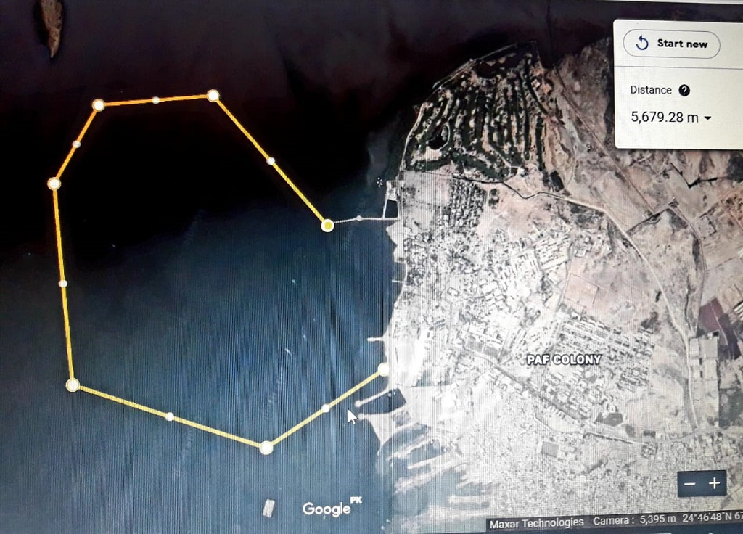

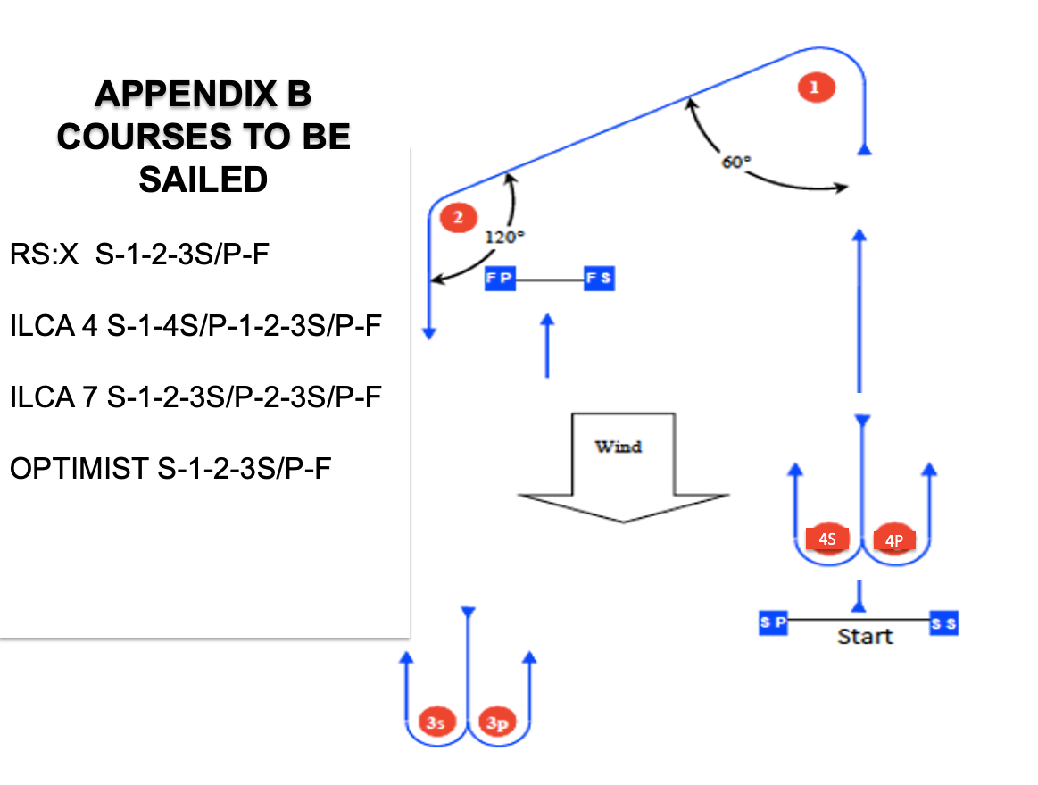

O 1

I 2

O 2

O 1

