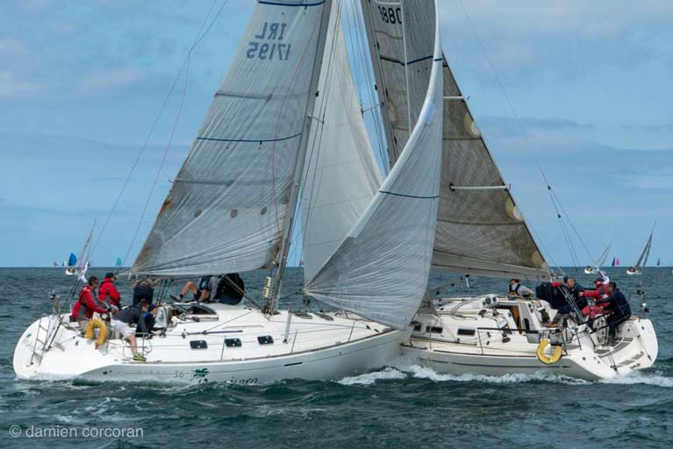
RED FLAG FLOWN IMMEDIATELY
PROTEST!
Figure 1 Starboard right of way boat protesting with an immediate hail of “PROTEST” and also immediately displaying a red flag flown conspicuously (typically at the backstay)
- IF YOU ARE AGGRIEVED AT AN INCIDENT ON WATER, AND YOUR BOAT IS GREATER THAN 6 METERS, THE PROTEST PROCEDURE ACCORDING TO RRS61.1 IS DESCRIBED BELOW.
- THE PROTEST IS INVALID IF NOT CARRIED OUT AS DESCRIBED.
- “AT THE FIRST REASONABLE OPPORTUNITY MEANS….ALMOST IMMEDIATELY.”
- KEEP THE FLAG FLYING UNTIL YOU HAVE CROSSED THE FINISH LINE AND NO LONGER RACING.
- IF THE OTHER PARTY EXONERATES HERSELF WITH A ONE TURN PENALTY, YOU MAY LOWER THE RED FLAG AS THE INCIDENT IS CLOSED.
61. PROTEST REQUIREMENTS
61.1. Informing the Protestee( Especially for for boats greater than 6 meters)
A boat intending to protest shall inform the other boat at the first reasonable opportunity. When her protest will concern an incident in the racing area that she was involved in or saw, she shall hail ‘Protest’ (not any other hail like, “hey, Oi, #$%& ”)and conspicuously display a red flag (not a red shirt, a red skirt, red shoe ) at the first reasonable opportunity for each. She shall display the flag until she is no longer racing. However,
  - if the other boat is beyond hailing distance, the protesting boat need not hail but she shall inform the other boat at the first reasonable opportunity;
  - if the hull length of the protesting boat is less than 6 metres, she need not display a red flag;
  - if the incident was an error by the other boat in sailing the course, she need not hail or display a red flag but she shall inform the other boat either before or at the first reasonable opportunity after the other boat finishes;
  - if as a result of the incident a member of either crew is in danger, or there is injury or serious damage that is obvious to the boat intending to protest, the requirements of this rule do not apply to her, but she shall attempt to inform the other boat within the time limit of rule 61.3.

